Mini Project 1: Network Security Design and Implementation

Table of Contents
1. Introduction 3
2. Objectives 3
3. Network Design using Cisco Packet Tracer 4
3.1 Topology Overview 4
3.2 IP Addressing Scheme 4
3.3 Router and Firewall Configuration 5
4. Vulnerability Assessment using Nessus 5
4.1 Installation and Setup 5
4.2 Scan Configuration 5
4.3 Results and Analysis 6
5. VPN Implementation using OpenVPN 6
5.1 VPN Concept 6
5.2 Configuration and Setup 6
5.3 Testing and Verification 7
6. Security Analysis and Discussion 7
7. Conclusion 7
8. References 8

1. Introduction
Network security is a critical aspect of modern information systems, ensuring the protection of data, devices, and communication channels from unauthorized access and cyber threats. With the increasing reliance on digital infrastructure, organizations must implement multiple layers of security to safeguard their networks. This project focuses on designing and implementing a secure network using simulation tools and real-world security technologies.
The project integrates three key components: network design and firewall implementation using Cisco Packet Tracer, vulnerability assessment using Nessus, and secure communication using OpenVPN. Together, these components provide a comprehensive understanding of network security principles and their practical application.

2. Objectives
The primary objectives of this project are:
- To design a secure network topology using Cisco Packet Tracer
- To implement routing and firewall rules for traffic control
- To perform vulnerability scanning using Nessus
- To establish a secure VPN connection using OpenVPN
- To analyze and evaluate the effectiveness of implemented security measures

3. Network Design using Cisco Packet Tracer

3.1 Topology Overview
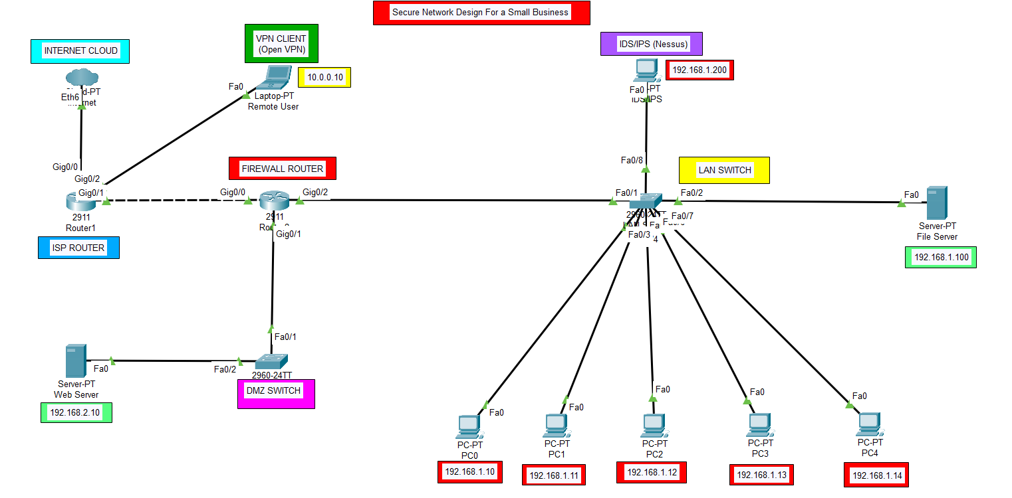
Figure: network design using cisco packet tracer
The network topology was designed using Cisco Packet Tracer and consists of multiple components including routers, switches, servers, and a remote user. The network is divided into three main segments:
- Internal LAN (Local Area Network)
- DMZ (Demilitarized Zone)
- External Network (Remote user)
Two routers were used to simulate real-world network architecture. One router acts as a gateway to the external network, while the other functions as a firewall controlling traffic between different network segments.

3.2 IP Addressing Scheme
A structured IP addressing scheme was implemented:
- LAN Network: 192.168.1.0/24
- DMZ Network: 192.168.2.0/24
- WAN Link: 172.16.0.0/30
Each device was assigned a unique IP address within its respective network. Proper subnetting ensured efficient routing and network organization.

3.3 Router and Firewall Configuration
Routing was configured using static routes to enable communication between networks. Additionally, Access Control Lists (ACLs) were applied to enforce security policies.
The firewall configuration included:
- Blocking access from the external network to the internal LAN
- Allowing HTTP and HTTPS traffic to the DMZ web server
- Permitting ICMP for testing purposes
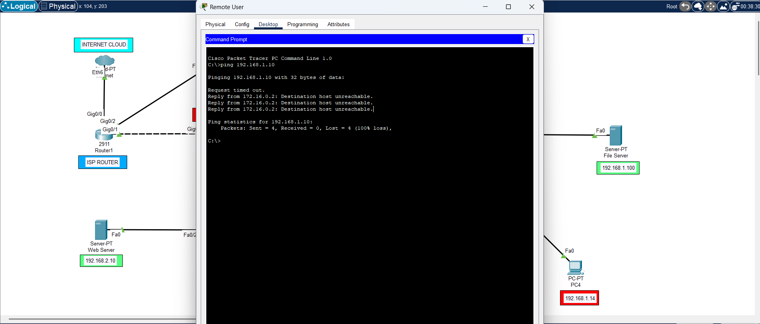
Figure: firewall blocking the pinging requests of the remote user
The effectiveness of the firewall was verified using ping tests. When the remote user attempted to access the internal LAN, the request was denied, confirming that the firewall rules were functioning correctly.

4. Vulnerability Assessment using Nessus

4.1 Installation and Setup
The vulnerability scanning tool Nessus was installed on Kali Linux. The installation process involved downloading the appropriate package, configuring the service, and accessing the web interface through a browser.
After installation, Nessus was activated using an activation key and configured for scanning.

4.2 Scan Configuration
A basic network scan was created to analyse the system for vulnerabilities. The target selected for scanning was the local system (127.0.0.1), which ensured safe and controlled testing.
The scan parameters included:
- Port scanning
- Service detection
- Vulnerability assessment
The scan was launched, and Nessus performed a comprehensive analysis of the system.
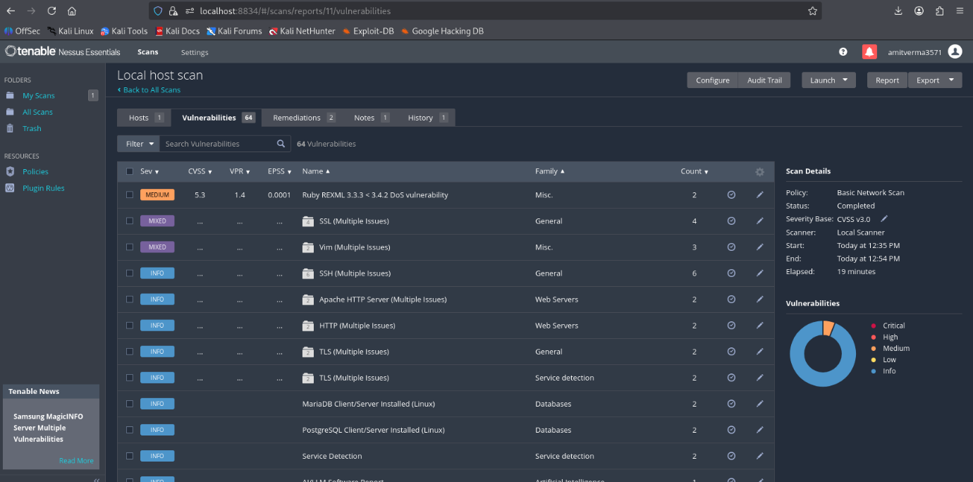
Figure: Local host (kali machine) scan

4.3 Results and Analysis
The scan results were categorized into different severity levels:
- Critical
- High
- Medium
- Low
The findings revealed several vulnerabilities, including open ports and outdated services. These vulnerabilities indicate potential entry points for attackers and highlight the importance of regular security assessments.
Nessus effectively demonstrated the role of intrusion detection systems by identifying weaknesses in the network environment.

5. VPN Implementation using OpenVPN

5.1 VPN Concept
A Virtual Private Network (VPN) provides secure communication over an insecure network by encrypting data and creating a secure tunnel between devices. This ensures confidentiality, integrity, and privacy of transmitted data.

5.2 Configuration and Setup
The VPN was implemented using OpenVPN on Kali Linux. A server-client model was used to establish the connection.
The configuration process included:
- Installing OpenVPN
- Creating configuration files for server and client
- Generating encryption keys
- Starting the VPN service
A static key method was used for simplicity and ease of implementation.

5.3 Testing and Verification
The VPN connection was established successfully, as indicated by the “Initialization Sequence Completed” message. A virtual network interface (tun0) was created, confirming the establishment of the VPN tunnel.
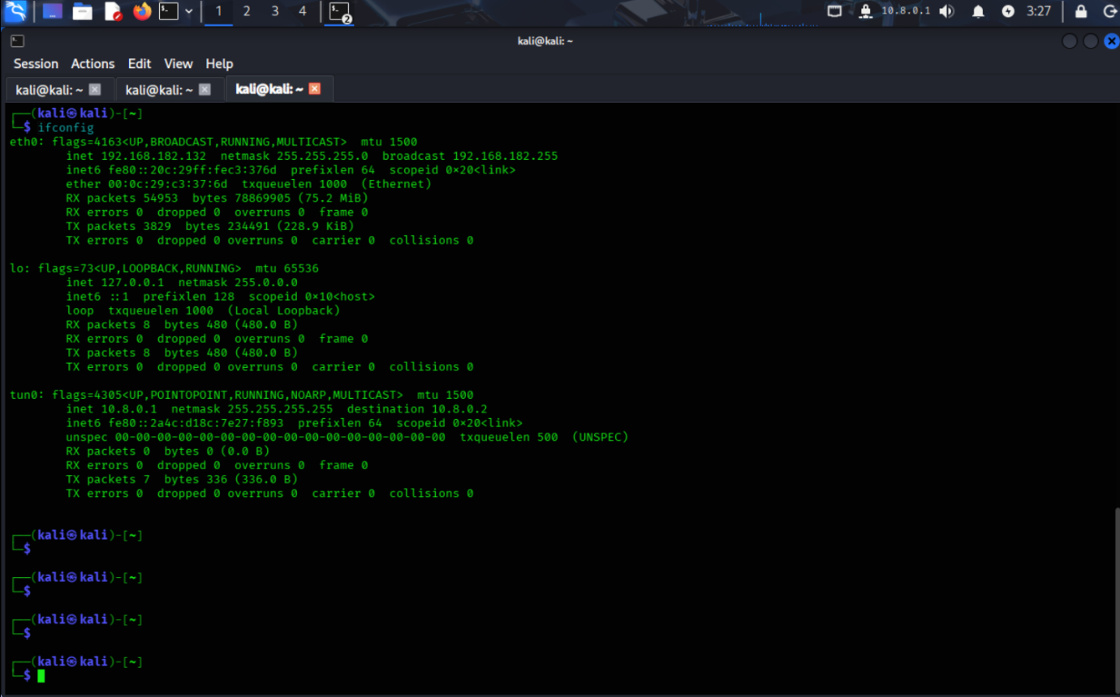
Figure: Successful tunnel (tun0) creation b/w server or client
The successful connection demonstrated secure communication between the client and server, ensuring that data transmitted over the network is encrypted and protected from unauthorized access.

6. Security Analysis and Discussion
The project successfully demonstrates multiple layers of network security:
- Firewall Security: Prevents unauthorized access to internal networks
- Vulnerability Assessment: Identifies weaknesses that could be exploited
- VPN Security: Ensures secure remote communication
The combination of these techniques provides a robust security framework. The firewall protects the internal network, Nessus identifies potential threats, and OpenVPN secures data transmission.
However, the project also highlights the importance of continuous monitoring and updates. Security threats evolve rapidly, and systems must be regularly assessed and updated to remain secure.

7. Conclusion
This project provided a comprehensive understanding of network security design and implementation. By integrating Cisco Packet Tracer, Nessus, and OpenVPN, a multi-layered security approach was achieved.
The network was successfully designed and secured using firewall rules, vulnerabilities were identified through scanning, and secure communication was established using a VPN. These implementations reflect real-world security practices and demonstrate the importance of a holistic approach to network security.
Overall, the project achieved its objectives and provided valuable insights into the practical application of network security concepts.

8. References
- Cisco Systems
Cisco Systems. (2023). Network Security Fundamentals. Retrieved from: https://www.cisco.com
- Tenable
Tenable. (2024). Nessus User Guide and Documentation. Retrieved from: https://www.tenable.com
- OpenVPN Inc.
OpenVPN Inc. (2024). OpenVPN Community Documentation. Retrieved from: https://openvpn.net

